Software related to picture Quality

- Simulation Project
http://singlepixelcamera2016.blogspot.com/
Stimulate the process of reconstruction of the image in the operation of a single pixel camera.

This project intends to simulate the process of reconstruction of the image in the operation of an single pixel camera. It used the implementation of terahertz pulsed spectroscopic imaging using optimized binary masks in MATLAB.

Project Objective and Mathematical Model
- Reconstruct the image with combining different patterns
- Process Large image in dividing the large images into small blocks
- Compare the reconstructed image and the original image to assess the quality of reconstruction.

For an Image with N = Ir x Ic pixels sampling with only M times (M < N), let x denote the vector signal of the input signal. Measurement process can be described as Y = betax, where y is an M x 1 measured vector Beta is an M x N binary matrix thus defining a M x N floating coefficient KLT matrix U with threshold value T.

Methodology:
- Choose an image and use imread to read and gets the image information, then change the length and width into the integer times of X
- Divide modified image into a number of M x N blocks using floor(size()/height or width), all of these blocks will be processed
- For each block, Which can be seen as the elements of the matrix, a random mask pattern will be set and combined with block in R, G, B dimensions using instruction mask*double(ima(;p,;,)). Next, use function linear_rec() to get three reconstruction block corresponding to R, G, B blocks are combined to get the processed block which is the new elements of the matrix.
- The elements of the Matrix are replaced by new elements to form a new matrix
- The new Matrix is processed by instruction imshow to display in the form of picture
- The similarity of two images is find using the comparison instruction ssim(image, newimage).

Results:
- Reconstruction with generated Image:
Using MATLAB, Process simple colour images. By doing this, you can Illustrate the number of masks changed to see the reconstructed quality.
- Reconstruction with small RGB Images:
Direct reconstruction of the image would cause distortion in the reconstructed image.
- Dividing the image and reconstruction:
Potentially change the algorithm to instead process a large image. As using MATLAB, it has its own limit on the size of the matrix which means in the process of dealing with the large image, MATLAB can’t process the operation of the large image because the mask pattern matrix is too large. For the small image, the use of the algorithm to divide them into blocks would increase the speed of processing.

In the GUI, it’d set the number of masks (for blocks of the image) and the block length. Additionally the program would return the value of the similarity between the reconstructed image and the original image

Conclusion:
In this project, the process is mainly about matrix calculations. Because MATLAB has its own limit on the size of the matrix, it was divided into small blocks to be process. Besides, our reconstruct routine only can conduct reconstruct image. On the stage, it was got some main summary about matrix process.

- In the same condition, the process speed would increase with the decrease of the length of the square sides.
- To process an image by dividing it into blocks, it would consume less time if it was divided into more blocks.

The relationship between mask, sampling rate and reconstructed quality is as below:

- If the number of masks is fixed, the higher sampling rate, the better reconstructed quality will be attained.
- If the sampling rate is fixed, the higher number of masks, the better reconstructed quality will be attained.
Part 1 –
Using the paper; Terahertz pulsed spectroscopic imaging using optimized binary masks authored by Dr. Y.C. Shen as the backbone for this simulation creation.

We learned some basic knowledge about this project, the function to process the images. The image can be processed by the points on the following:

- For one specific image with fixed pixels, the first thing is to determine the numbers of the pixels.
- Divide the image into several parts.
- Create the mask pattern with pixels.
- Combined the original image with the mask pattern.
- Reconstruct the image and output the reconstructed image.

With the increasement of the mask patterns, the quality becomes better which illustrates the relationship between the mask patterns and the reconstructed image is linear.

The result of the program with the mask pattern size 90, 180, 270 is attached at the end.

The flow chart is on the following:

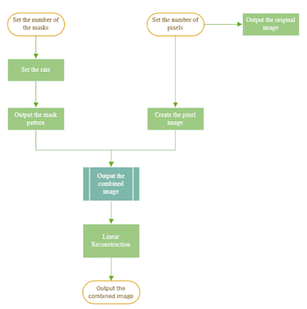
Code –
% test linear_rec(THzData, MaskData)
clear all;
% sample pattern
NP=40; % number of pixels
ima=zeros(NP);ima(:,1:3)=1; ima(:,14:16)=1; ima(:,24:26)=1; ima(:,38:40)=1; ima(1:3,:)=1;ima(14:16,:)=1;ima(24:26,:)=1; ima(38:40,:)=1; %establish a 32*32 zero matrix,sample pattern
figure(1),subplot(2,2,1),imagesc(ima), title('original image')
% simulate mask set data
NM=90; % nunmber of masks

% mask data
MaskData=zeros(NM,NP*NP);
subplot(2,2,2),im1=imagesc(ima);title('mask pattern')
subplot(2,2,3),im2=imagesc(ima);title('combined')
for i=1:NM
temp=rand(NP); temp=temp>0.5;
MaskData(i,:)= temp(:);
pause(0.1)
temp1=reshape(temp,NP,NP);%mask pattern
set(im1,'CData',temp1);
temp=temp1.*ima; %combined patten
set(im2,'CData',temp);
end

% THz data
THzData=MaskData*ima(:); % simulate terahertz measurement data
% reconstruction
newimg=linear_rec(THzData, MaskData); % call the reconstruciton function
% reifne and plot
newimg=squeeze(newimg);
newimg=newimg.*(newimg>0);
figure(1);subplot(2,2,4),imagesc(newimg);% display the reconstructed image
title('Results of Linear Reconstruction');
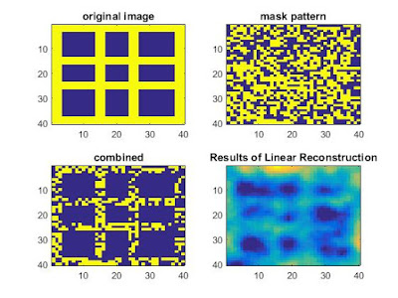
The result of 90 Mask Pattern

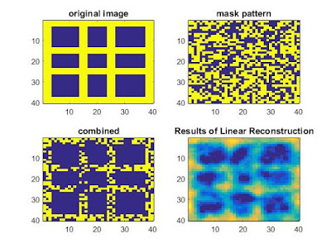
The result of 180 Mask Pattern

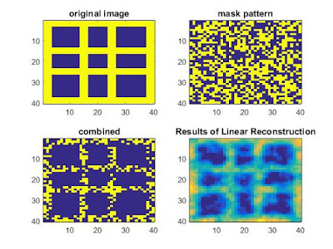
The result of 270 Mask Pattern
Part 2 –
Used MATLAB to create a simple image containing 1600 pixels. The masks of the image increased from 100 to 1650 and the quality of the linear reconstruction varied with the masks increasing. The flowchart of this week's progress can be seen on the following:

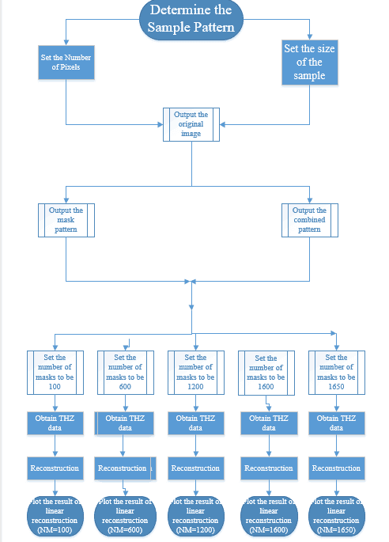

Function to pass the parameter of the mask numbers so the function can call the parameter to do different reconstruction of different mask patterns. When the mask number is less than the total pixels of the image, the quality of linear reconstructed image becomes better as the mask number increased. If the mask number exceeds the pixels, the linear reconstruction cannot complete.
The result can be seen on the following:

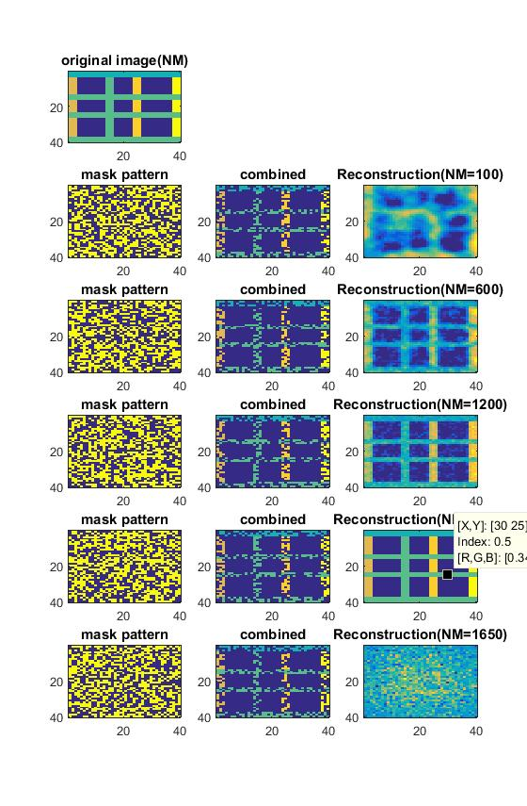
For the first part focusing on the reconstructed image and the pixels, the code can is attached on the following, it is divided into 2 parts, the main function and the combined function.

% test linear_rec(THzData, MaskData)
clear all;

% sample pattern
NP=40; % number of pixels
ima=zeros(NP);ima(:,1:3)=1; ima(:,14:16)=1; ima(:,24:26)=1; ima(:,38:40)=1; ima(1:3,:)=1;ima(14:16,:)=1;ima(24:26,:)=1; ima(38:40,:)=1; %establish a 32*32 zero matrix,sample pattern
figure(1),subplot(6,3,1),imagesc(ima), title('original image(NM)')
% simulate mask set data
NM=100; % nunmber of masks
x=1;
test(ima, NM, NP, x );

NM=600; % nunmber of masks
x=2;
test(ima, NM, NP, x );
NM=1200; % nunmber of masks
x=3;
test(ima, NM, NP, x );
NM=1600; % nunmber of masks
x=4;
test(ima, NM, NP, x );
NM=1650; % nunmber of masks
x=5;
test(ima, NM, NP, x );

Function

function test(ima, NM, NP, x ) %[ ima, imga, imgb, imgc ] =
subplot(6,3,3*x+1),imga=imagesc(ima);title('mask pattern')
subplot(6,3,3*x+2),imgb=imagesc(ima);title('combined')
a=3*x+1;
b=3*x+2;
c=3*x+3;
MaskData=zeros(NM,NP*NP);

for i=1:NM
temp=rand(NP); temp=temp>0.5;
MaskData(i,:)= temp(:);
%pause(0.1)
tempa=reshape(temp,NP,NP);%mask pattern
set(imga,'CData',tempa);
tempb=tempa.*ima; %combined patten
set(imgb,'CData',tempb);
end
THzData=MaskData*ima(:); % simulate terahertz measurement data
% reconstruction
newimg=linear_rec(THzData, MaskData); % call the reconstruciton function
% reifne and plot
newimg=squeeze(newimg);
newimg=newimg.*(newimg>0);
subplot(6,3,3*x+3),imgc=imagesc(newimg);title(['Reconstruction(NM=' , num2str(NM), ')']);

end

Part 3 –

